The Numbers Classes

When working with numbers, most of the time you use the primitive types in your code. There are, however, reasons to use objects in place of primitives, and the Java platform provides wrapper classes for each of the primitive data types. These classes "wrap" the primitive in an object. Often, the wrapping is done by the compiler—if you use a primitive where an object is expected, the compiler boxes the primitive in its wrapper class for you. Similarly, if you use a number object when a primitive is expected, the compiler unboxes the object for you.

Note: There are four other subclasses of Number that are not discussed here. BigDecimal and BigInteger are used for high-precision calculations. AtomicInteger and AtomicLong are used for multi-threaded applications.

There are three reasons that you might use a Number object rather than a primitive:
- As an argument of a method that expects an object (often used when manipulating collections of numbers).
- To use constants defined by the class, such as MIN_VALUE and MAX_VALUE, that provide the upper and lower bounds of the data type.
- To use class methods for converting values to and from other primitive types, for converting to and from strings, and for converting between number systems (decimal, octal, hexadecimal, binary).

To format a string containing numbers for output, you can use the printf() or format() methods in the PrintStream class.
Like in C , you can use format() or printf() (these are the same) anywhere in your code where you have previously been using print or println.
Format specifiers begin with a percent sign (%) and end with a converter. The converter is a character indicating the type of argument to be formatted. In between the percent sign (%) and the converter you can have optional flags and specifiers.

%n and \n are the same (?) → a platform-independent newline character.

Math Class

The Math class in the java.lang package provides methods and constants for doing more advanced mathematical computation. The methods in the Math class are all static, so you call them directly from the class, like this:
Math.cos(angle);
Some methods in this class are :
- abs (absolute value), ceil , floor , round , min , max , rint , log , pow , sqrt ...

Random numbers : The random() method returns a pseudo-randomly selected number between 0.0 and 1.0. The range includes 0.0 but not 1.0. To get a number in a different range, you can perform arithmetic on the value returned by the random method.
For example, to generate an integer between 0 and 9, you would write:
int number = (int)(Math.random() * 10);
By multiplying the value by 10, the range of possible values becomes 0.0 <= number < 10.0.
Character (java.lang)
There are times, when you need to use a char as an object—for example, as a method argument where an object is expected. The Java programming language provides a wrapper class that "wraps" the char in a Character object for this purpose.
An object of type Character contains a single field, whose type is char. This Character class also offers a number of useful class (i.e., static) methods for manipulating characters.
- The Java compiler will also create a Character object for you under some circumstances. For example, if you pass a primitive char into a method that expects an object, the compiler automatically converts the char to a Character for you. This feature is called autoboxing—or unboxing, if the conversion goes the other way.
- Note: The Character class is immutable, so that once it is created, a Character object cannot be changed.
Some usefull Character class methods (static) :
- isLetter(char ch) , isDigit(char ch), isWhitespace, isUpperCase, isLowerCase, toUpperCase, toLowerCase, toString …
Same escape Sequences :
- \t → tab , \b → backspace , \n → newline
\r → move the position of the cursor to the first position on the same line without advancing downward.
\f → formfeed : automatically advance one full page or to the start of the next page. Used as Page seperator / Section seperator
\’ \\ \” → escaping these characters
Strings
Sequence of characters. Strings are objects. The Java platform provides the String class to create and manipulate strings.
Note: The String class is immutable, so that once it is created a String object cannot be changed. The String class has a number of methods, that appear to modify strings. Since strings are immutable, what these methods really do is create and return a new string that contains the result of the operation.
- length() → returns the number of characters contained in the string object
- charAt(i) → which returns the i ’ th character in the string, counting from 0.
- getChars() → to convert a string, or a portion of a string, into an array of characters
- string1.concat(string2); “bla”+“Bla” → returns string1 added string2 to it at the end
Note: The Java programming language does not permit literal strings to span lines in source files, so you must use the + concatenation operator at the end of each line in a multi-line string.
For example:
String quote =
"Now is the time for all good " +
"men to come to the aid of their country.";
Breaking strings between lines using the + concatenation operator is, once again, very common in print statements.
Using String's static format() method allows you to create a formatted string that you can reuse, as opposed to a one-time print statement. String fs; fs = String.format(“blaaa….”);
System.out.println(fs);
Converting Strings to Numbers

The Number subclasses that wrap primitive numeric types ( Byte, Integer, Double, Float, Long, and Short) each provide a class method named valueOf that converts a string to an object of that type.
- Returns an OBJECT of that type
- valueOf(int i) − This returns an Integer object holding the value of the specified primitive.
- valueOf(String s) − This returns an Integer object holding the value of the specified string representation.
Integer x =Integer.valueOf(9); // returns an Integer obj
Double c = Double.valueOf(5); // returns an Double obj
Float a = Float.valueOf("80");

Note: Each of the Number subclasses that wrap primitive numeric types also provides a parseXXXX() method (for example, parseFloat()) that
- can be used to convert strings to primitive numbers. Returns a primitive type.
Since a primitive type is returned instead of an object, the parseFloat() method is more direct than the valueOf() method. We could use:
float a = Float.parseFloat(“22”);
float b = Float.parseFloat(args[1]);

Converting Numbers to Strings

There are several easy ways to convert a number to a string:

int i;
// Concatenate "i" with an empty string; conversion is handled for you.
String s1 = "" + i;

or

// The valueOf class method.
String s2 = String.valueOf(i);

Each of the Number subclasses includes a class method, toString(), that will convert its primitive type to a string.

int i = 22 ; // primitive type to string , using class method
String str = Integer.toString(i);

same here

Integer i = 22;
String str = i.toString(); // DONT access a class method with an obj
String str = Integer.toString(i); // this is the correct way

Manipulating Characters in a String

The String class has a number of methods for examining the contents of strings, finding characters or substrings within a string, changing case, and other tasks.

String str = “hey there”;

str.charAt(6); → ‘e’
str.substring(4); → “there” Returns a new string , including 4 - till end
str.substring(4,6); → “th” Returns a new string , including 4 - excluding 6

str.trim(); Returns a copy of this string with leading and trailing white space removed.

str.toLowerCase(); Returns a copy of this string converted to lowercase or upercase str.toUpperCase(); If no conversions are necessary, these methods return the original string.

Searching for Characters and Substrings in a String

str.indexOf(int ch) Returns the index of the first (last) occurrence of the character.
str.lastIndexOf(int ch)

str.indexOf(String str) Returns the index of the first (last) occurrence of the substring.
str.lastIndexOf(String str)

str.indexOf(int ch, int fromIndex) Starts to search from the given index, forwards str.indexOf(String str, int fromIndex) /backwards

str.contains(CharSequence s) Returns true if the string contains the character sequence.
Also a String can be passed as an argument

Replacing Characters and Substrings into a String

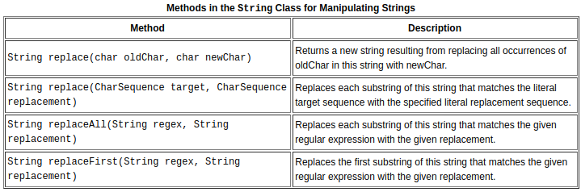

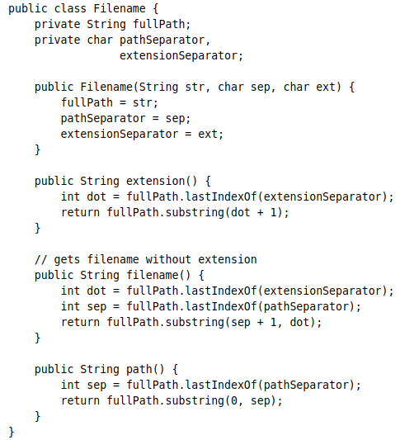
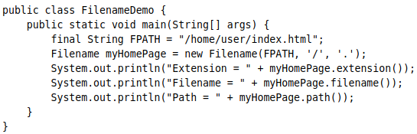

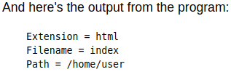

Comparing Strings and Portions of Strings

boolean endsWith(String suffix) Returns true if this string ends with or begins with the boolean startsWith(String prefix) substring specified as an argument to the method.

boolean startsWith(String prefix, int offset) Considers the string beginning at the index offset

int compareTo(String anotherString) Compares two strings lexicographically. <0 == 0 >0

int compareToIgnoreCase(String str) Ignoring differences in case

boolean equals(Object anObject) Returns true if and only if the argument is a String object that represents the same sequence of characters as this object.

boolean equalsIgnoreCase(String anotherString)

Returns true if and only if the argument is a String object that represents the same sequence of characters as this object, ignoring differences in case.

The StringBuilder Class

StringBuilder objects are like String objects, except that they can be modified. Internally, these objects are treated like variable-length arrays that contain a sequence of characters. At any point, the length and content of the sequence can be changed through method invocations.

Strings should always be used unless string builders offer an advantage in terms of simpler code (see the sample program at the end of this section) or better performance. For example, if you need to concatenate a large number of strings, appending to a StringBuilder object is more efficient.
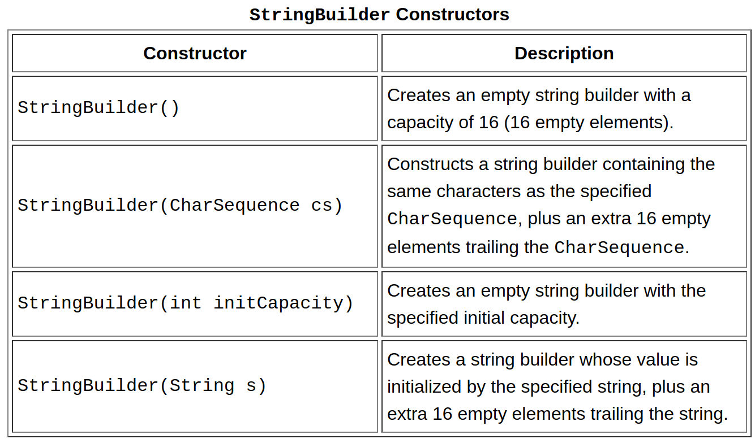

StringBuilder B = new StringBuilder();

B.append(5);
B.append(‘+’);
B.append(4.9);
B.append(‘=’);
B.append(4.9+5);
System.out.println(B); // 5 + 4.9=9.9

delete(int start, int end)
deleteCharAt(int index)

insert(int offset, boolean b)
insert(int offset, char c)
insert(int offset, Object obj)
insert(int offset, String str)
...

reverse() Reverses the sequence of characters in this string builder.

toString() Returns a string that contains the character sequence in the builder.

- Note: You can use any String method on a StringBuilder object by first converting the string builder to a string with the toString() method of the StringBuilder class. Then convert the string back into a string builder using the StringBuilder(String str) constructor.

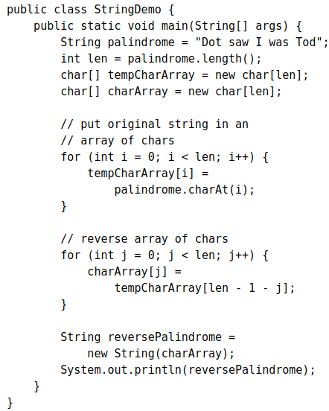
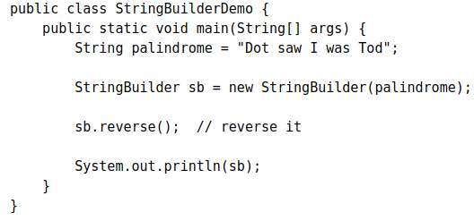

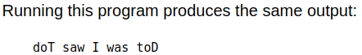

To accomplish the string reversal, the program converts the string to an array of characters (first for loop), reverses the array into a second array (second for loop), and then converts back to a string. If you convert the palindrome string to a string builder, you can use the reverse() method in the StringBuilder class. It makes the code simpler and easier to read

Note that println() prints a string builder, as in: System.out.println(sb); because sb.toString() is called implicitly, as it is with any other object in a println() invocation.

Note: There is also a StringBuffer class that is exactly the same as the StringBuilder class, except that it is thread-safe by virtue of having its methods synchronized. Threads will be discussed in the lesson on concurrency.

Wrapper class in java provides the mechanism to convert primitive into object and object into primitive. Since J2SE 5.0, autoboxing and unboxing feature converts primitive into object and object into primitive automatically.
The automatic conversion of primitive into object is known as autoboxing and vice-versa unboxing.

The eight classes of java.lang package are known as wrapper classes in java. The list of eight wrapper classes are given below:
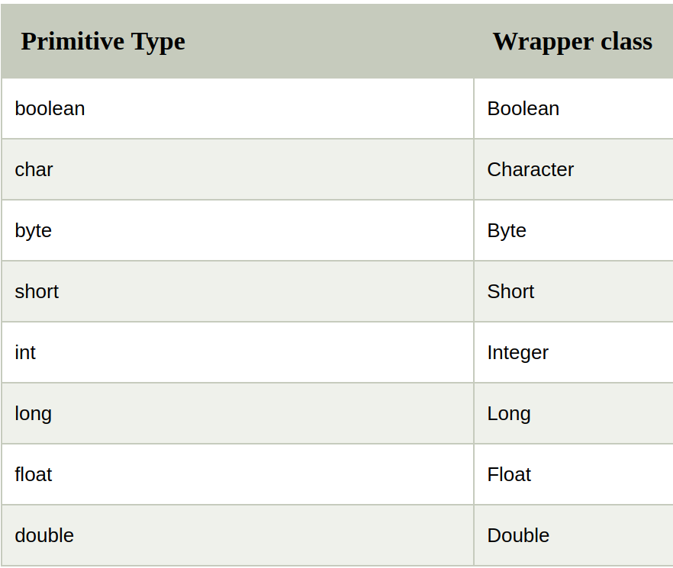

Autoboxing and Unboxing

Autoboxing is the automatic conversion that the Java compiler makes between the primitive types and their corresponding object wrapper classes. For example, converting an int to an Integer, a double to a Double, and so on. If the conversion goes the other way, this is called unboxing.
Here is the simplest example of autoboxing: Character ch = 'a';

The Java compiler applies autoboxing when a primitive value is:
- Passed as a parameter to a method that expects an object of the corresponding wrapper class.
- Assigned to a variable of the corresponding wrapper class.

The Java compiler applies unboxing when an object of a wrapper class is:
- Passed as a parameter to a method that expects a value of the corresponding primitive type.
- Assigned to a variable of the corresponding primitive type.

Consider the following code (autoboxing) :

List<Integer> li = new ArrayList<>();
for (int i = 1; i < 50; i += 2)
li.add(i);

Although you add the int values as primitive types, rather than Integer objects, to li, the code compiles. Because li is a list of Integer objects, not a list of int values, you may wonder why the Java compiler does not issue a compile-time error. The compiler does not generate an error because it creates an Integer object from i and adds the object to li. Thus, the compiler converts the previous code to the following at runtime:

List<Integer> li = new ArrayList<>();
for (int i = 1; i < 50; i += 2)
li.add(Integer.valueOf(i));

unboxing :
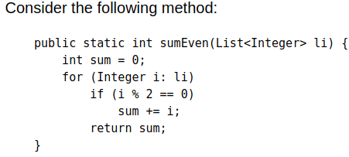

Because the remainder (%) and unary plus (+=) operators do not apply to Integer objects, you may wonder why the Java compiler compiles the method without issuing any errors. The compiler does not generate an error because it invokes the intValue method to convert an Integer to an int at runtime:

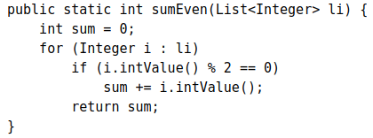

Packages

To make types easier to find and use, to avoid naming conflicts, and to control access, programmers bundle groups of related types into packages.

Definition: A package is a grouping of related types providing access protection and name space management. Note that types refers to classes, interfaces, enumerations, and annotation types. Enumerations and annotation types are special kinds of classes and interfaces, respectively, so types are often referred to in this lesson simply as classes and interfaces.

Suppose you write a group of classes that represent graphic objects, such as circles, rectangles, lines, and points. You also write an interface, Draggable, that classes implement if they can be dragged with the mouse.

You should bundle these classes and the interface in a package for several reasons, including the following:
- You and other programmers can easily determine that these types are related.
- You and other programmers know where to find types that can provide graphics-related functions.
- The names of your types won't conflict with the type names in other packages because the package creates a new namespace.
- You can allow types within the package to have unrestricted access to one another yet still restrict access for types outside the package.

To create a package, you choose a name for the package (naming conventions are discussed in the next section) and put a package statement with that name at the top of every source file that contains the types (classes, interfaces, enumerations, and annotation types) that you want to include in the package.

The package statement (for example, package graphics;) must be the first line in the source file. There can be only one package statement in each source file, and it applies to all types in the file.

Note: If you put multiple types in a single source file, only one can be public, and it must have the same name as the source file. For example, you can define public class Circle in the file Circle.java, define public interface Draggable in the file Draggable.java, define public enum Day in the file Day.java, and so forth. (interfaces can be public or package private)

You can include non-public types in the same file as a public type (this is strongly discouraged, unless the non-public types are small and closely related to the public type), but only the public type will be accessible from outside of the package. All the top-level, non-public types will be package private.

→ For all types , make a seperate file

Naming Conventions

- Package names are written in all lower case to avoid conflict with the names of classes or interfaces.
- Companies use their reversed Internet domain name to begin their package names—for example, com.example.mypackage for a package named mypackage created by a programmer at example.com.
- Packages in the Java language itself begin with java. or javax.
- In some cases, the internet domain name may not be a valid package name :
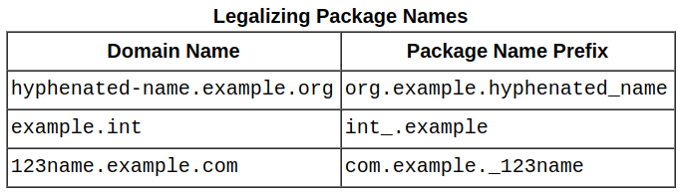

Using Package Members

To use a public package member from outside its package, you must do one of the following:
- Refer to the member by its fully qualified name : for not frequent use , if that member has not been imported , graphics.Rectangle , we can now use the Rectangle class from graphics package
- Import the package member: import graphics.Rectangle; Now you can refer to the Rectangle class by its simple name
- Import the member's entire package: To import all the types contained in a particular package import graphics.*; Asterisk (*) is a wildcard.

Apparent Hierarchies of Packages

At first, packages appear to be hierarchical, BUT THEY ARE NOT. For example, the Java API includes a java.awt package, a java.awt.color package, a java.awt.font package, and many others that begin with java.awt. However, the java.awt.color package, the java.awt.font package, and other java.awt.xxxx packages are not included in the java.awt package. The prefix java.awt (the Java Abstract Window Toolkit) is used for a number of related packages to make the relationship evident, but not to show inclusion.

Importing java.awt.* imports all of the types in the java.awt package, but it does not import java.awt.color, java.awt.font, or any other java.awt.xxxx packages. If you plan to use the classes and other types in java.awt.color as well as those in java.awt, you must import both packages with all their files:
import java.awt.*;
import java.awt.color.*;

Name Ambiguities

If a member in one package shares its name with a member in another package and both packages are imported, you must refer to each member by its qualified name.

The Static Import Statement

There are situations where you need frequent access to static final fields (constants) and static methods from one or two classes. Prefixing the name of these classes over and over can result in cluttered code. The static import statement gives you a way to import the constants and static methods that you want to use so that you do not need to prefix the name of their class.

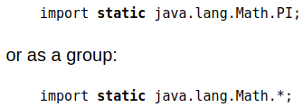
You can use the static import statement to import the static members of java.lang.Math so that you don't need to prefix the class name, Math.

Note: Use static import very sparingly. Overusing static import can result in code that is difficult to read and maintain, because readers of the code won't know which class defines a particular static object. Used properly, static import makes code more readable by removing class name repetition.

Managing Source and Class Files

The strategy is as follows.

- Put the source code for a class, interface, enumeration, or annotation type in a text file whose name is the simple name of the type and whose extension is .java.
- Then, put the source file in a directory whose name reflects the name of the package to which the type belongs.

The qualified name of the package member and the path name to the file are parallel, assuming the Microsoft Windows file name separator backslash
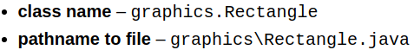

- If both files you need are in the same package , you can just compile the one with the main function normally and it will work.
javac Hello.java
java Hello
- If both files you need are in the same package, you can access methods etc with their direct names (if they are public or package-private), no need to import them to be able to use them

- You don't have to import classes that are in the same package as the current class.

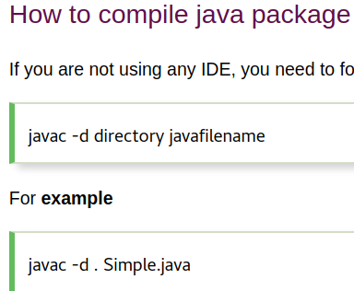

The -d switch specifies the destination where to put the generated class file. You can use any directory name like /home (in case of Linux), d:/abc (in case of windows) etc. If you want to keep the package within the same directory, you can use . (dot).

package name; should be the first line in every file

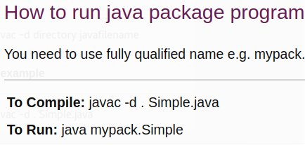

Dont forget, FIRST COMPILE THE CLASSES THAT YOU USE IN YOUR MAIN CLASS and last COMPILE YOUR MAIN CLASS or else your main function wont find the classes / interfaces that you try to access

Classpath

Like the .java source files, the compiled .class files should be in a series of directories that reflect the package name. However, the path to the .class files does not have to be the same as the path to the .java source files. You can arrange your source and class directories separately, as:
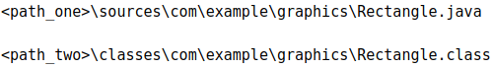

By doing this, you can give the classes directory to other programmers without revealing your sources. You also need to manage source and class files in this manner so that the compiler and the Java Virtual Machine (JVM) can find all the types your program uses.
- It would be impractical to have the VM look through every folder on your machine, so you have to provide the VM a list of places to look. This is done by putting folder and jar files on your classpath.
- Meaning when you put something like import org.javaguy.coolframework.MyClass; the JVM wont know for sure in which folder this org.javaguy … packages are. So we are telling him where to look for those packages by setting adding them to the classpath variable.

The full path to the classes directory, <path_two>\classes, is called the class path, and is set with the CLASSPATH system variable. Both the compiler and the JVM construct the path to your .class files by adding the package name to the class path.

For example, if
<path_two>\classes
is your class path, and the package name is
com.example.graphics,
then the compiler and JVM look for .class files in <path_two>\classes\com\example\graphics.
A class path may include several paths, separated by a semicolon (Windows) or colon (UNIX). By default, the compiler and the JVM search the current directory and the JAR file containing the Java platform classes so that these directories are automatically in your class path.

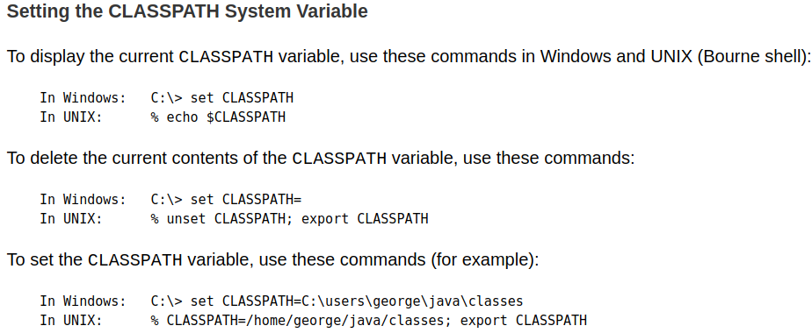

PATH is an environmental variable in Linux and other Unix-like operating systems that tells the shell which directories to search for executable files.

The PATH environment variable is a series of directories separated by semicolons (;). Microsoft Windows looks for programs in the PATH directories in order, from left to right. You should have only one bin directory for the JDK in the path at a time (those following the first are ignored)

my PATH variable looks like this ( echo $PATH) :
/usr/local/sbin:/usr/local/bin:/usr/sbin:/usr/bin:/sbin:/bin:/usr/games:/usr/local/games:/snap/bin

- If you do not set the PATH variable, you need to specify the full path to the executable every time you run it, such as: /usr/local/jdk1.7.0/bin/javac MyClass.java

- I set the PATH variable , my ‘java’ and ‘javac’ commands are in /usr/bin so I dont need to specify the full path to the command each time when I want to use it like /usr/binjavac MyClass.java instead we can just write javac MyClass.java
from anywhere and it will look through the PATH variable to find that executable ‘javac

Setting PATH variable , permanently

/etc/environment file , It's sole purpose is to store Environment Variables . So you can just open this file as root and add whatever you want.

Or

PATH=$PATH:~/opt/bin // adding at the end saving this to a file or export (?)
PATH=~/opt/bin:$PATH // adding at the beginning

Difference between PATH and CLASSPATH in Java

- The main difference between PATH and CLASSPATH is that PATH is an environment variable which is used to locate JDK binaries like "java" or "javac" command used to run java program and compile java source file. On the other hand, CLASSPATH, an environment variable is used by System or Application ClassLoader to locate and load compile Java bytecodes stored in the .class file.
- PATH environment variable is used by operating system to find any binary or command typed in the shell, this is true for both Windows and Linux environment while CLASSPATH is only used by Java ClassLoaders to load class files.
- Another significant difference between PATH and CLASSPATH is that PATH can not be overridden by any Java settings but CLASSPATH can be overridden by providing command line option -classpath or -cp to both "java" and "javac" commands or by using Class-Path attribute in Manifest file inside JAR archive.

The CLASSPATH variable is one way to tell applications, including the JDK tools, where to look for user classes.

Normally the CLASSPATH is set to ‘.’ meaning that the jvm looks to the current folder first (?)

When we set the CLASSPATH to a different folder , the java command will start to look there for our .java files.

Overriding the CLASSPATH variable can be done while execution : java -classpath . Hello

Generics

Fortunately, some bugs are easier to detect than others. Compile-time bugs, for example, can be detected early on; you can use the compiler's error messages to figure out what the problem is and fix it, right then and there. Runtime bugs, however, can be much more problematic; they don't always surface immediately, and when they do, it may be at a point in the program that is far removed from the actual cause of the problem.
Generics add stability to your code by making more of your bugs detectable at compile time.

In a nutshell, generics enable types (classes and interfaces) to be parameters when defining classes, interfaces and methods. Much like the more familiar formal parameters used in method declarations, type parameters provide a way for you to re-use the same code with different inputs.
- The difference is that the inputs to formal parameters are values, while the inputs to type parameters are types.

Why use Generics ?

Code that uses generics has many benefits over non-generic code:

- Stronger type checks at compile time. A Java compiler applies strong type checking to generic code and issues errors if the code violates type safety. Fixing compile-time errors is easier than fixing runtime errors, which can be difficult to find.

- Elimination of casts. The following code snippet without generics requires casting:
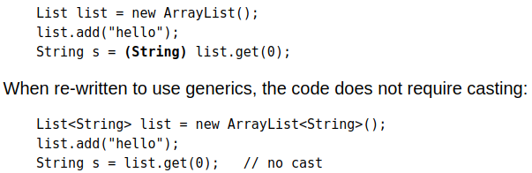

- Enabling programmers to implement generic algorithms. By using generics, programmers can implement generic algorithms that work on collections of different types, can be customized, and are type safe and easier to read.

→ Compile time checking , the whole point

→ generics can be used also with Interfaces

→ the <T1, T2, ...Tn> are called type parameters (also called type variables), type variable T
→ A type variable can be any non-primitive type you specify: any class type, any interface type, any array type, or even another type variable.
→ Type parameter naming conventions : Single , uppercase letters . E - Element , K – Key , N – Number , T – Type , V – Value, S U V etc – 2nd,3rd , 4th types
Invoking and Instantiating a Generic Type
To reference the generic Box class from within your code, you must perform a generic type invocation, which replaces T with some concrete value, such as Integer: Box<Integer> integerBox;
You can think of a generic type invocation as being similar to an ordinary method invocation, but instead of passing an argument to a method, you are passing a type argument — Integer in this case — to the Box class itself.
Like any other variable declaration, this code does not actually create a new Box object. It simply declares that integerBox will hold a reference to a "Box of Integer", which is how Box<Integer> is read.
An invocation of a generic type is generally known as a parameterized type. Meaning when we create an object of a generic class with a type Box<Integer> intBox = new Box<>();
To instantiate this class, use the new keyword, as usual, but place <Integer> between the class name and the parenthesis: Box<Integer> integerBox = new Box<Integer>();

Type Parameter and Type Argument Terminology: They are NOT the same
Many developers use the terms "type parameter" and "type argument" interchangeably, but these terms are not the same. When coding, one provides type arguments in order to create a parameterized type. Therefore, the T in Foo<T> is a type parameter and the String in Foo<String> f is a type argument.

The diamond : In Java SE 7 and later, you can replace the type arguments required to invoke the constructor of a generic class with an empty set of type arguments (<>) as long as the compiler can determine, or infer, the type arguments from the context. This pair of angle brackets, <>, is informally called the diamond.

- A raw type is the name of a generic class or interface without any type arguments, so its a not parameterized.
- Generic methods are methods that introduce their own type parameters. This is similar to declaring a generic type, but the type parameter's scope is limited to the method where it is declared. Static and non-static generic methods are allowed, as well as generic class constructors.

Understanding Generic Classes

A generic class expects also a type. If we wont provide a type in the declaration then it is considered a raw Type .
When we define for example an ArrayList this is a Generic Class :
ArrayList myList = new ArrayList(); or List myList = new ArrayList();
myList.add(“Hello”); myList.add(22); myList.add(false);
This is called a raw type.
Meaning that I can add anything I want to this list. A string , an integer and so on. Adding different data types to this collection. We are using a raw type in this case , meaning that
- anything goes to the list will be considered an OBJECT , it WONT be considered the type that we put in , a string or an integer.
- If we want to get any of the elements in the list with myList.get(index); we will get an OBJECT type back.

String str = myList.get(0); → We know its a string “Hello” that is the first element in the List but the compiler will give an error “type mismatch”, because we try to assign an OBJECT to a STRING reference.
In this case we have to cast it , we have to specify that this is a String and it will work :
String str = (String) myList.get(0);

Here are the problems :

The second element in the list is an integer but Java doesn’t know that , it only sees Objects in there. If we fool the compiler now by writing
String str1 = (String) myList.get(1);
It thinks our integer element is now a String.

- Casting each Element to its correct type is really time consuming and not easy
- Runtime Errors might occur by not correct references to differeny types which is extremely bad , we rather fix compile time errors.

Solution :

Thats why we use generic classes. We write the code once and then when we define our objects and references accordingly , we can say with which type we want to work with. No other types will be allowed and the compiler will also know the type.

List <String> myList = new ArrayList<String>();
or
List <String> myList = new ArrayList<>();

- Now we told the compiler that we will work ONLY with String objects. No other types can be added to the Array List (integer , boolean …)

String str = myList.get(0); → This will return a String , no need for casts

public class test <K,V> { public <U> void oneMethod (){
// implementation
private K key; }
private V value;
// this is how the syntax is
public void setKey(K key){ // using generic types with methods !
this.key = key;
}
public void setValue(V value){
this.value = value;
}
public K getKey(){
return this.key;
}
public V getValue(){
return this.value;
}
// in main ...
// this instance of the class test<K,V> will work with String and Double as key and value type
test<String, Double> myTestObject = new test<>();
myTestObject.setKey("Can");
myTestObject.setValue(100.2);

// this instance of the class test<K,V> will work with Boolean and String as key and value type
test<Boolean, String> myTestObject2 = new test<>();
myTestObject2.setKey(true);
myTestObject2.setValue(“hi”);

// we can even do this , our first type is a Boolean, our second type is a test class with String and Double types

test<Boolean,test<String,Double >> myTestObject2 = new test<>(); myTestObject2.setKey(true);
myTestObject2.setValue(myTestObject);

// myTestObject is an object of the class test with types <String,Double> so we can pass it here as a parameter

Bounding certain Types

In the example above any type can be used as K or V. But in certain scenarios that wont be optimal.

Adding bounds to a generic type : Multiple bounds possible : <T extends B1 & B2 & B3>

public <U extends Number> void inspect (U u){

System.out.println(u.getClass().getName());
}

Now the Upper bound is the class Number ! Meaning that this Method will only accept the class Number or the Subclasses of number such as Integer , Double , Float and so on.

<U extends String> Now only String objects are allowed

The wildcards helps to make generic types even more flexible and less restrictive
<? extends Number> <? super Number>

